SHA-512 Secure Hash Algorithm
Aim
To implement the SHA-512 secure hash algorithm to compute a 512-bit message digest.
Algorithm
- Initialize Variables: Set up eight 64-bit working variables (H0 through H7) using fractional parts of the square roots of the first 8 primes.
- Message Padding: Pad the message so its length is congruent to $896 \left(mod 1024\right)$, appending a 128-bit block representing the original message length.
- Message Schedule: Parse the 1024-bit block into 16 64-bit words, expanding them into 80 words using sigma functions ($σ_{0},σ_{1}$).
- Compression Loop: Run 80 rounds of mixing operations using choice, majority, and rotation functions.
- Final Result: Add the output of the block loop to the original state variables and output the combined 512-bit hash.

Program:
#include <stdio.h>
#include <string.h>
#include <openssl/sha.h>

int main() {
char string[] = "NetworkSecurityLab";
unsigned char digest[SHA512_DIGEST_LENGTH];

// Compute SHA-512 hash
SHA512((unsigned char*)string, strlen(string), digest);

printf("--- SHA-512 HASH EXPERIMENT ---\n");
printf("Input String: %s\n", string);
printf("SHA-512 Digest (Hex): \n");

for(int i = 0; i < SHA512_DIGEST_LENGTH; i++) {
printf("%02x", digest[i]);
}
printf("\n");

return 0;
}
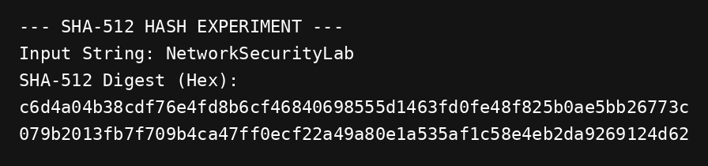
Result:
thus the program has successfully executed and compiled with perfect output.

